**Let.Me.Out.**

After attending a Music Current festival organized by Dublin Sound Lab in 2019, I was inspired by the commissioned works that included electronic and choreographic elements. *Sideshow* by Steven Kazuo Takasugi has highly influenced me to explore music in combination with electronic elements and mime acting. Hence, this led me to compose a work for accordion and tape (processed electronic sound), with mime acting involved.

The work is structured in ternary form with a coda. The first section introduces percussive textures that imitate the electronic sound world. Also, the performer is asked to mime robotically, to create an uncanny alienation. The second section is more pitch-based in comparison to the first section, while the mime acting becomes more involved. The first section returns in a more developed manner and it combines with material from the second section in the second half. Lastly, the work ends with a chaotic coda containing all the materials from the work juxtaposed together.

The rhythm is more important in this work, whereas the pitch material is secondary. This work applies the single line contour stave, found in the notation of *Workers’ Union* by Louis Andriessen, which represents the middle register of the accordion for both hands. However, this work mixes the single line contour stave with the conventional stave to indicate notes.

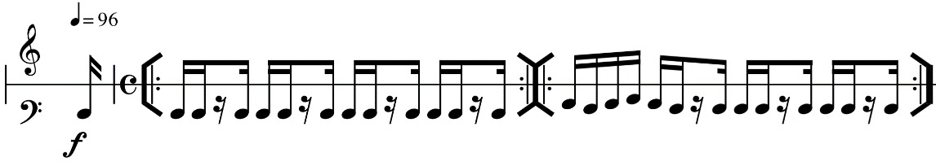

Figure 1: Workers’ Union’s notation

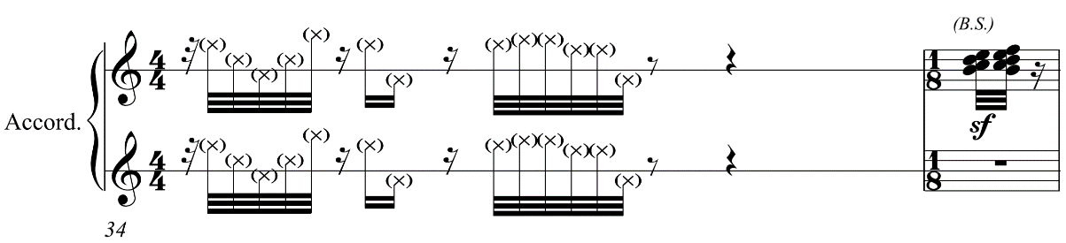

Figure 2: Let.Me.Out.’s notation

Besides that, the rhythmic material of the work is mainly based on the motive shows below. This motive is retrograded, fragmented, and reordered fragments in the work.

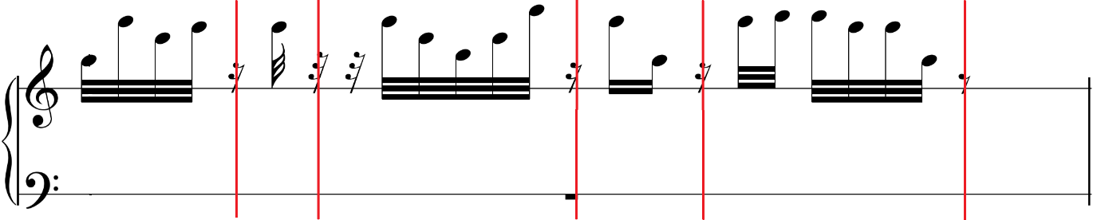

Figure 3: The main rhythmic motive of Let.Me.Out.

The process of making the tape requires a lot of collaborations with the performer, as several sounds are needed to be recorded from the accordion. However, the meetings were unexpectedly cancelled, due to the Covid-19 lockdown. Hence, I made a provisional tape and obtained all the sounds through freesound.org and Sibelius’s sound library. Although some sounds are hard to imitate, such as button clicks, I used the equalizer and the reverb to change the timbre of the sample to make the sound as similar as possible through Cubase.

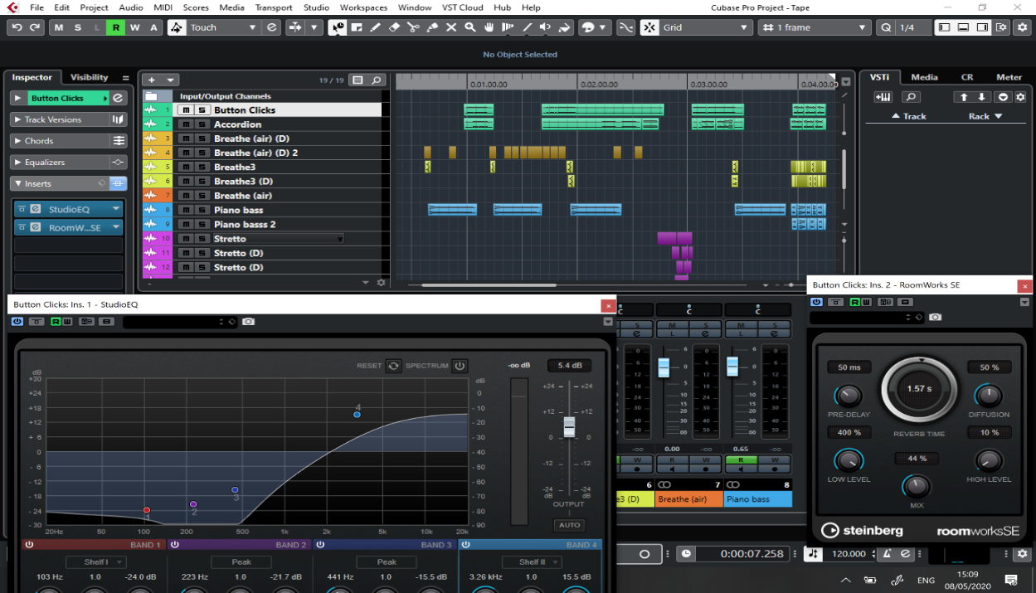

Figure 4: Equalizer and Reverb are employed in Cubase

The sound effect of the performance direction “*air sound with gaps*” is inspired by flickering lights. The intention of this is to turn the visual effect into an audio effect, to create a disordered feeling.

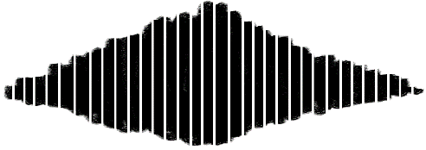

Figure 5: Example of air sound with gaps